Charts and Studies

Version 8.7

May 2022

# 

About this Guide

This guide provides detailed information about the charts and studies (technical indicators) included in the ChartIQ library.

Audience

The *Charts and Studies* guide is intended for chart users, such as chartists and technical and data analysts. For information about the ChartIQ chart user interface, see the *ChartIQ User Guide*. For information about software application development, see the [charting library documentation](https://documentation.chartiq.com/).

Contents

Chart Styles and Types **1**

Chart Styles **4**

Line 4

Colored line 5

Bar 5

Colored bar 6

Candle 6

Hollow candle 7

Volume candle 8

Mountain 8

Baseline delta 9

Time series scatter 10

HLC box chart 11

Chart Types **12**

Customizing chart types 12

Heikin-Ashi 12

Kagi 14

Line break 15

Point and figure 16

Range bars 16

Renko 17

Additional Charts **18**

Term Structure 18

Data Forecasting 19

Studies **20**

Popular studies 20

Anchored VWAP 20

Aroon / Aroon Oscillator 20

Average Directional Index and Directional Movement System (ADX/DMS) 21

Average True Range (ATR) 22

Bollinger Bands 22

GoNoGo Trend 23

Moving Average 23

Moving Average Convergence Divergence (MACD) 24

Option Sentiment by Strike 25

Projected Aggregate Volume 26

Projected Volume at Time 28

Relative Strength Index (RSI) 30

Stochastics 30

Supertrend 31

Volume 31

All studies 32

# Chart Styles and Types

The charting library supports a variety of chart styles and types.

Chart styles are the various ways that a chart can visually represent data; for example, as a candle, line, or mountain graph.

Chart types are charts that display data that has been modified through aggregation or recalculation; for example, Heikin-Ashi, Kagi, and point and figure charts.

In some cases, a chart type includes a chart style. For instance, a point and figure chart aggregates data while requiring a specific display style.

You can switch between chart styles and types without disturbing the chart state. For example, drawings and studies are maintained as you change from chart to chart, enabling you to alter your view but keep your work. The charts automatically adjust the scale and positioning of drawings and study lines as appropriate for the chart type.

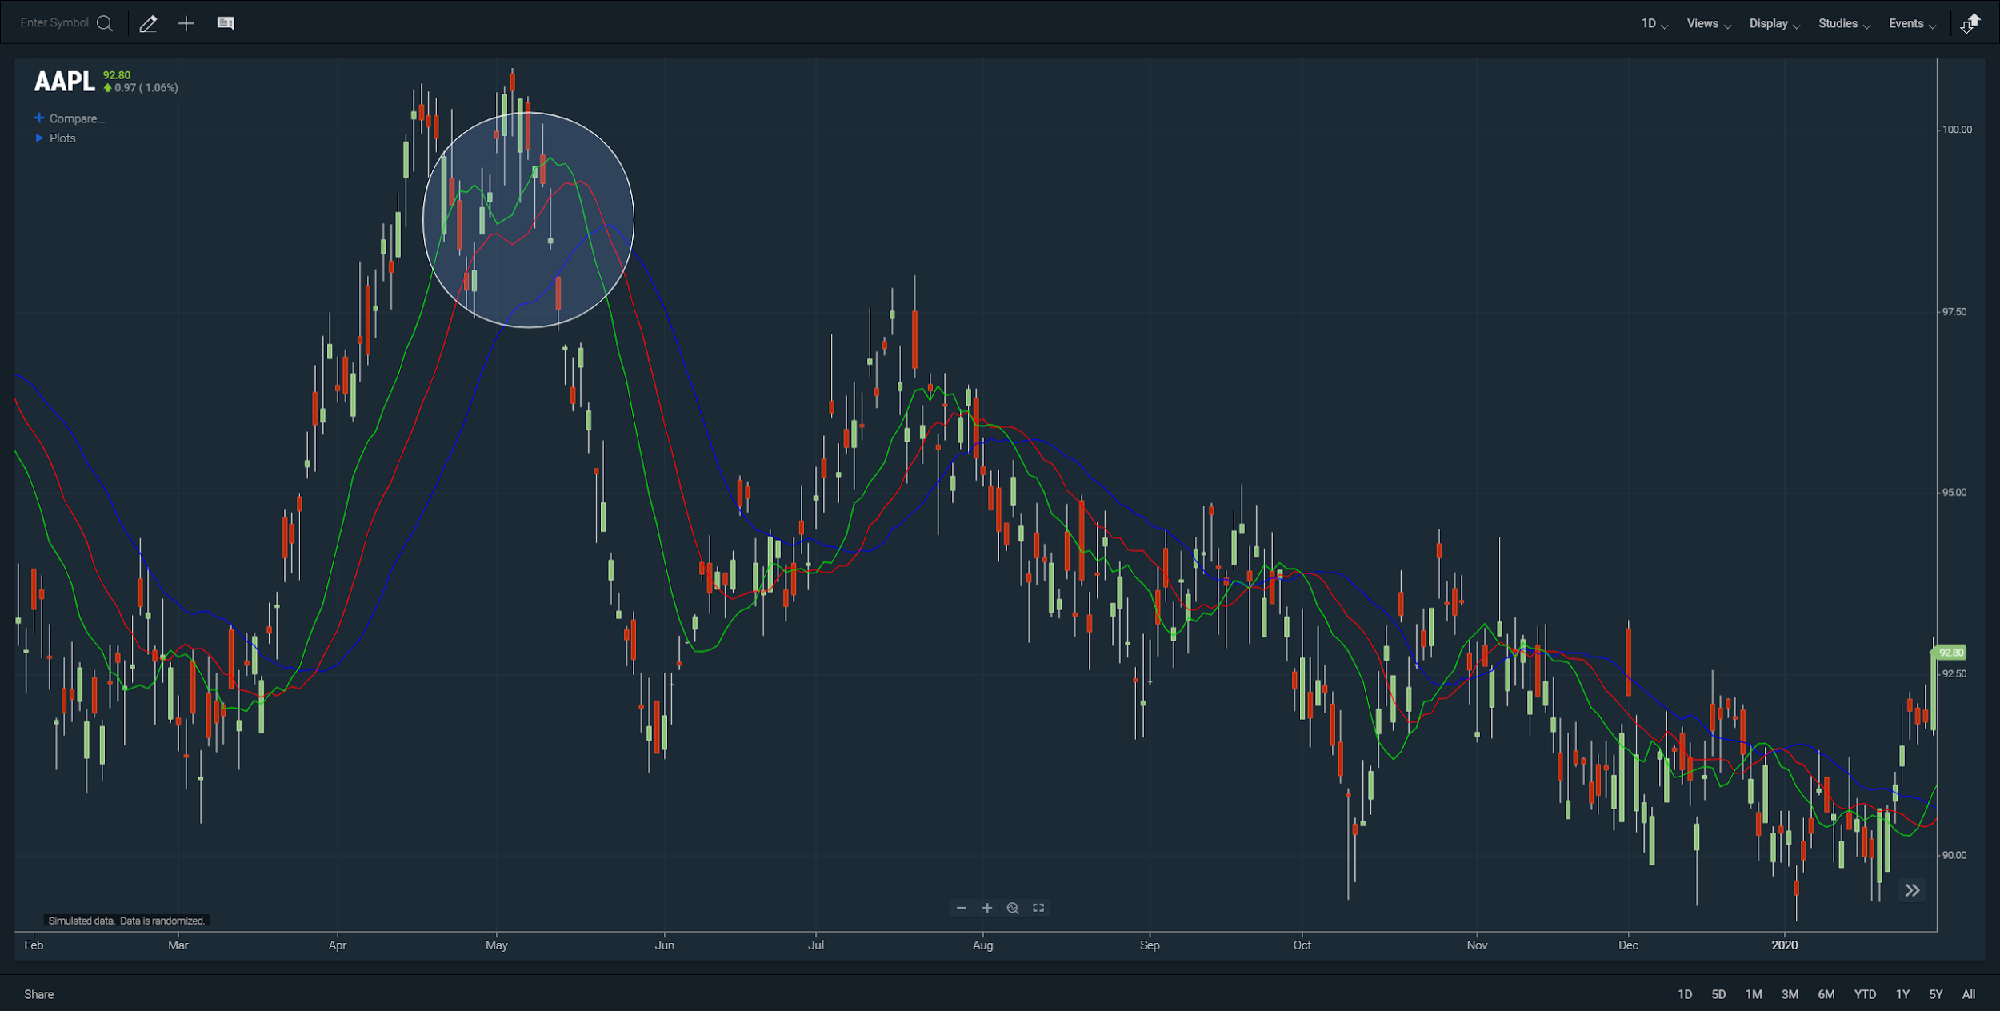

***Figure.*** *Candle chart with Alligator study and circle.*

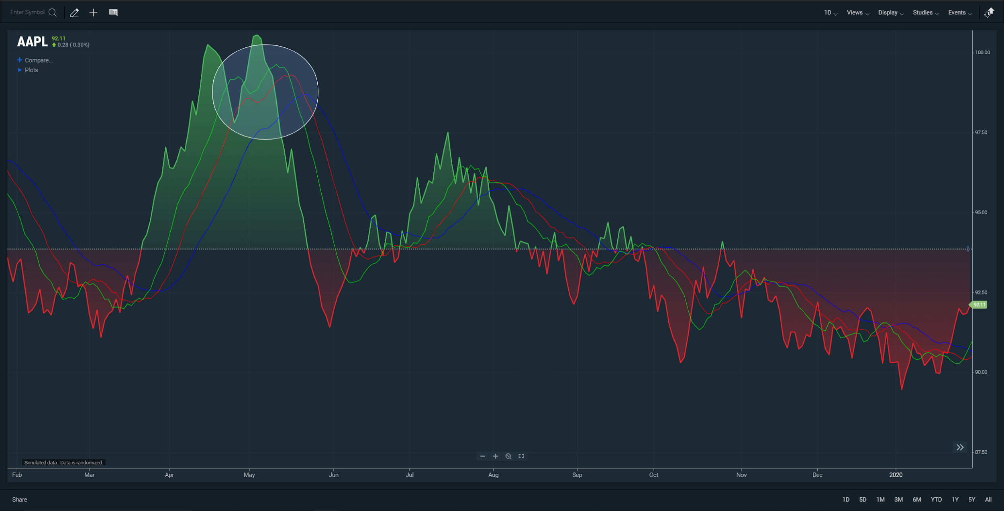

***Figure.*** *Baseline chart with Alligator study and circle.*

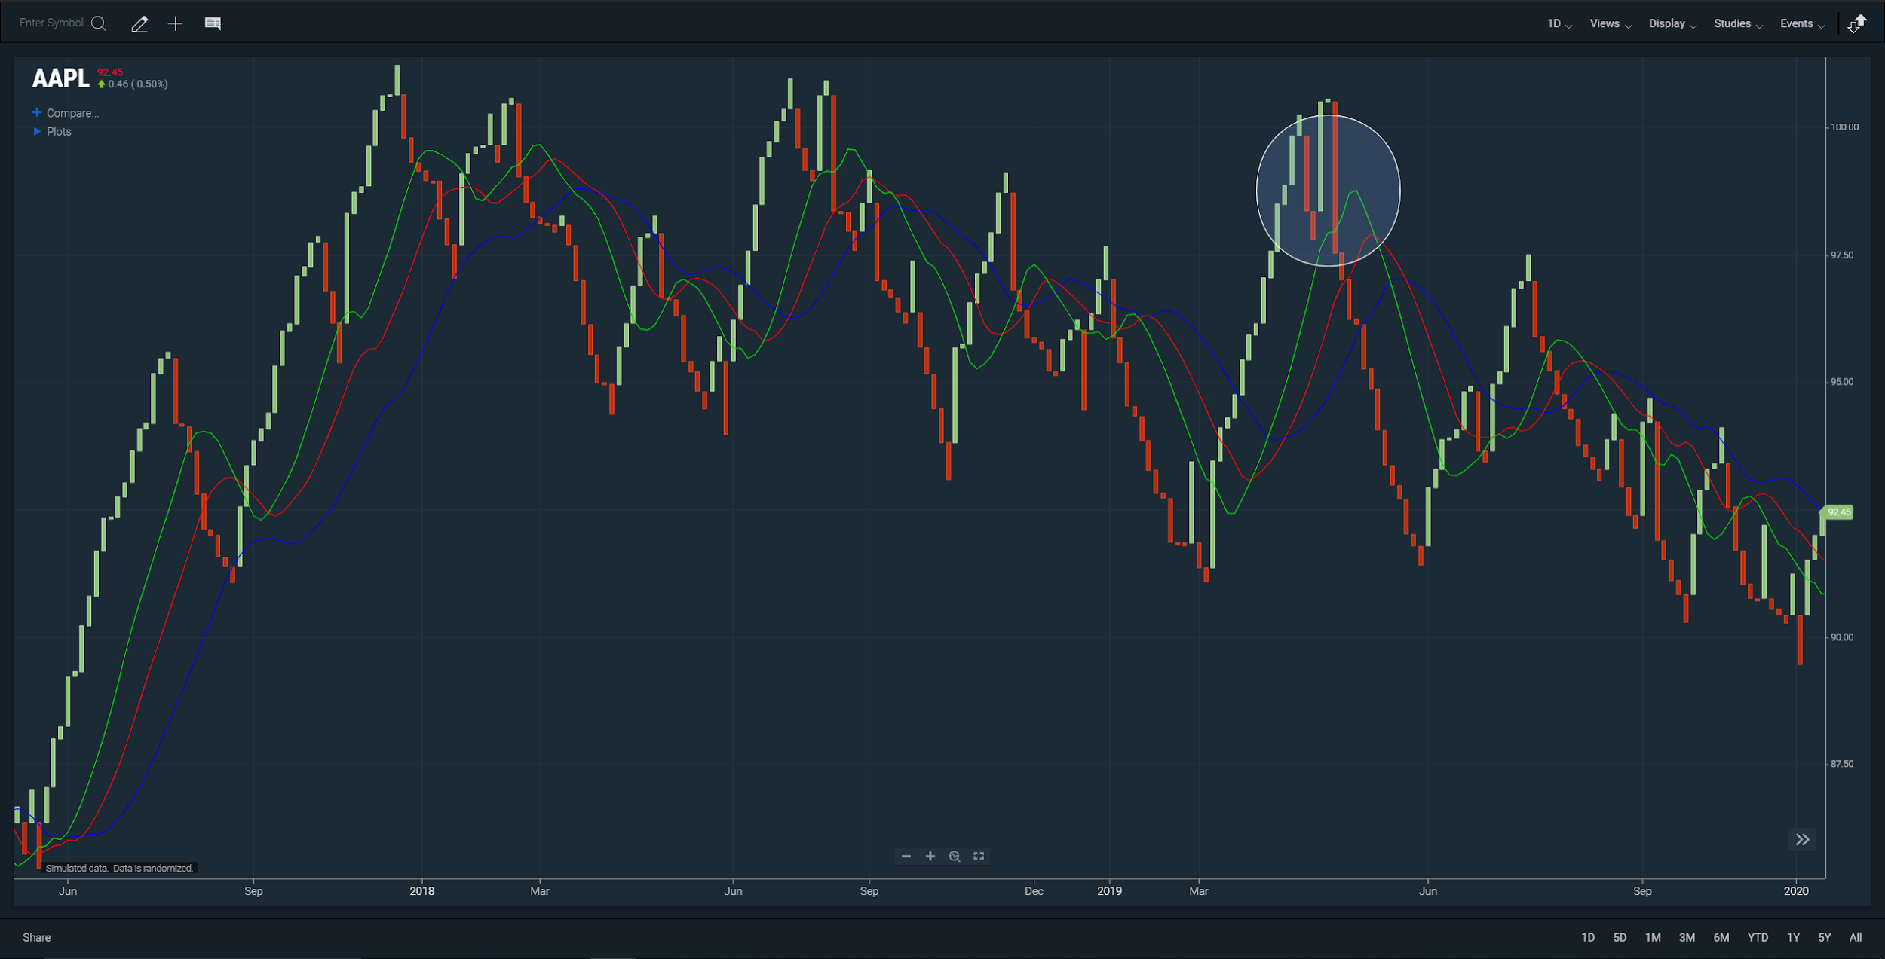

***Figure.*** *Line break chart with Alligator study and circle.*

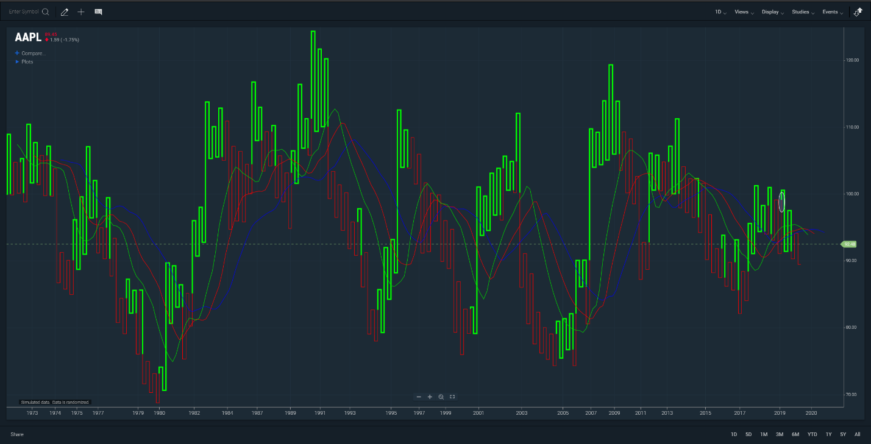

***Figure.*** *Kagi chart with Alligator study and circle (on far right).*

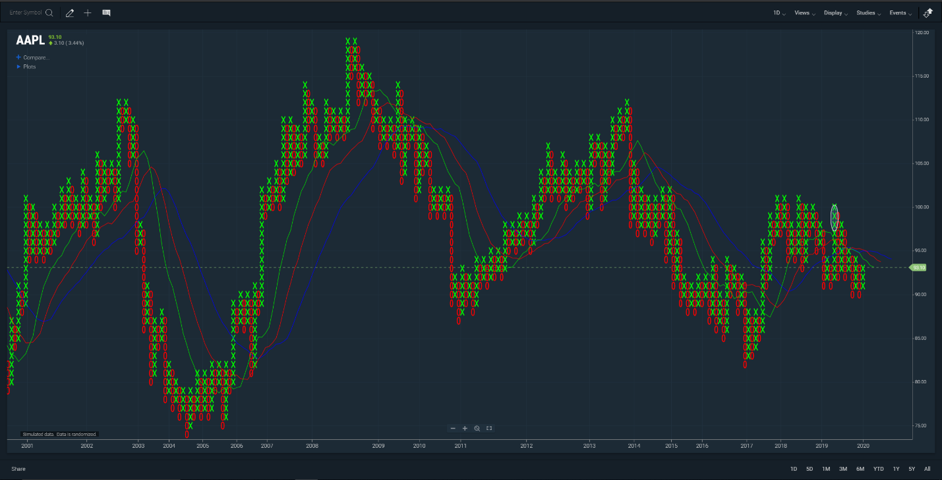

***Figure.*** *Point and figure chart with Alligator study and circle (on far right).*

# 

# Chart Styles

## Line

A line chart consists of segments that connect at the close price for each time period. The line is a single color. Any value in your data that has a null value for close will result in a gap within the line.

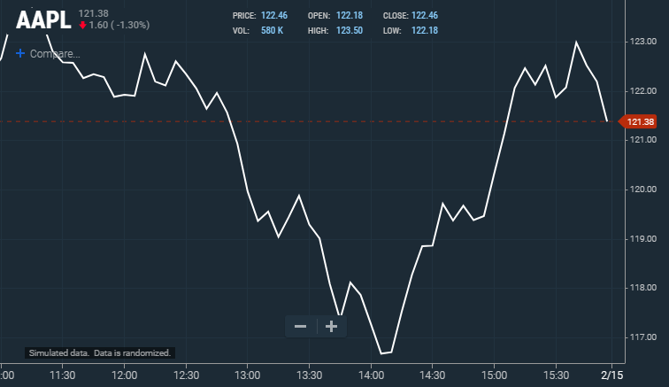

## Colored line

Like the line chart, the colored line is a line chart with segments of various colors. Each color indicates a price action. If the close for a period is higher than that of the previous close, the line between the periods is shaded green. If the close is lower than the previous close, the line between the periods is shaded red. If the close was equal to the previous close, the line between the periods is shaded gray. (The image below uses a step line drawing style.)

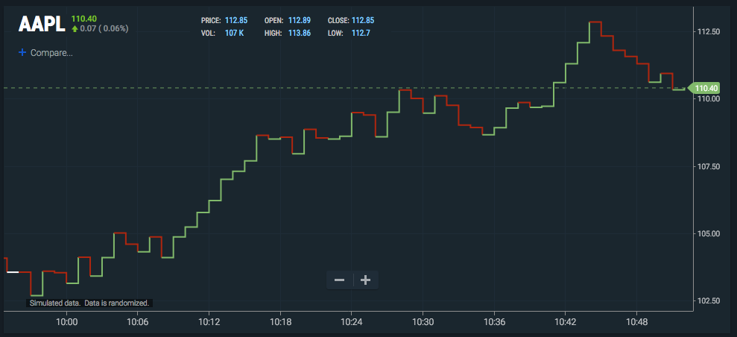

## Bar

Bar charts consist of vertical lines sandwiched between two shelves. One bar is created for each interval (period) on the chart. Each bar represents the OHLC (open, high, low, close) for the period. The top and bottom of the vertical line represent the high and low for the period. The left shelf is the opening price while the right shelf is the closing price. The bars are a single color.

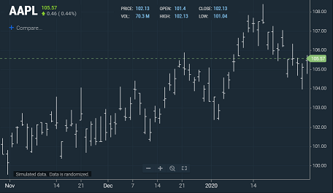

## Colored bar

A colored bar chart draws a bar chart with the bars colored to indicate price action. The algorithm is the same as colored line (see below).

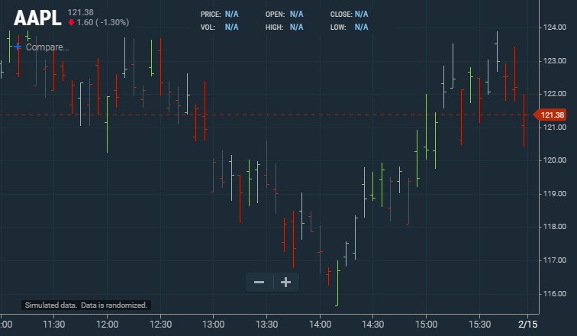

## Candle

Like bar charts, candle charts represent OHLC, except in the form of colored rectangles called candles. When the open is lower than the close, the candle is shaded green. When the open is higher than the close, the candle is shaded red. If the open and close are the same, a thin horizontal line segment is drawn at that price (this type of candle is called a “doji”). Each candle has a “wick” that extends above and below the candle to indicate the high and low, respectively.

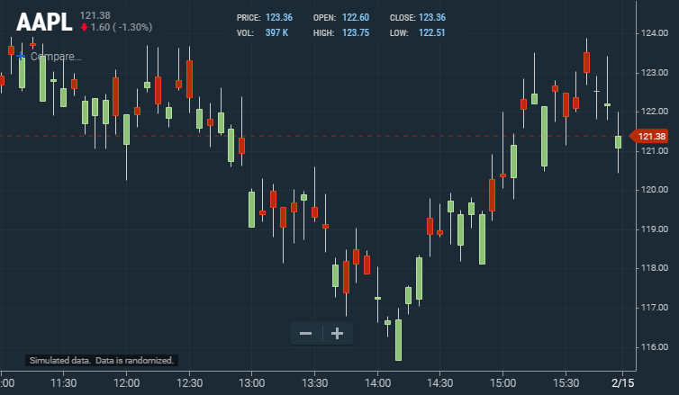

## Hollow candle

Hollow candle charts are a special type of candle chart that displays additional information and changes the meaning of the colors. In a hollow candle chart, a green candle occurs when the closing price is higher than the prior bar’s closing price. It is red when the closing price is lower than the prior bar’s closing price.

The candles are either filled or hollow based on the price action within the candle. Hollow candles are drawn when the close is higher than the open (upward intra-session price action). The candle is filled when the close is lower than the open (downward intra-session price action). If the close is the same as the open, only a gray horizontal line is drawn.

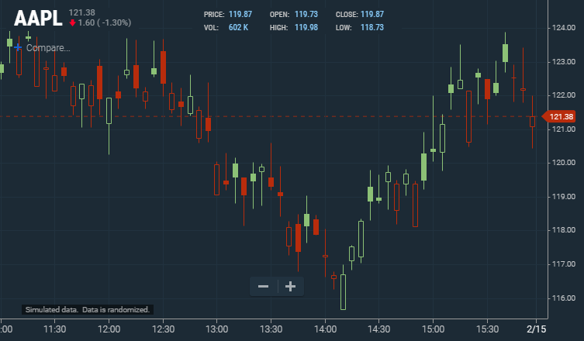

## Volume candle

A volume candle chart is a hollow candle chart where the width of a candle varies to indicate volume. Each candle’s shading and fill follow the same conventions as those in hollow candle charts. Wide candles indicate high volume while narrow candles indicate low volume.

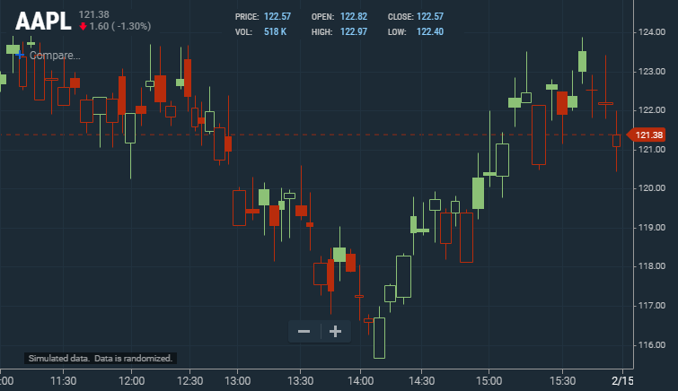

## Mountain

Mountain charts (sometimes called area charts) are line charts with a shaded section that extends to the bottom of the chart. The result is a chart which looks like a mountain.

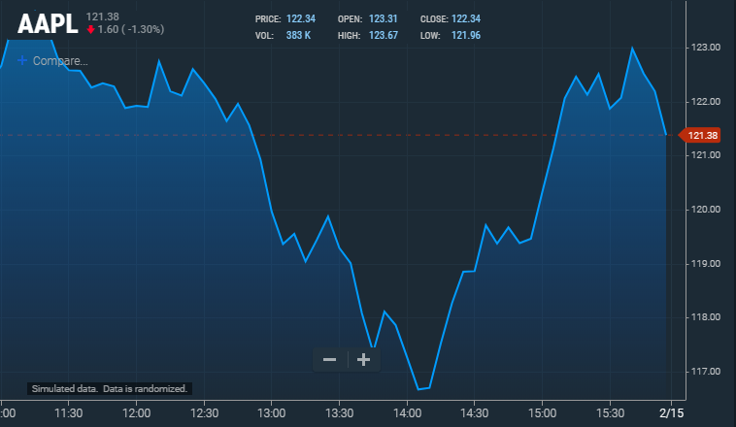

## Baseline delta

A baseline delta chart draws a line chart that oscillates across a dotted baseline. The area above the baseline is shaded green, and the area below the baseline is shaded red. The baseline initializes to the left most closing value on the chart but can be adjusted by dragging the handle located on the right side of the chart. This chart style is meant to highlight the positive and negative distance from the set baseline. It is typically used for intraday charts where the left side (baseline) is set to the opening of the market day.

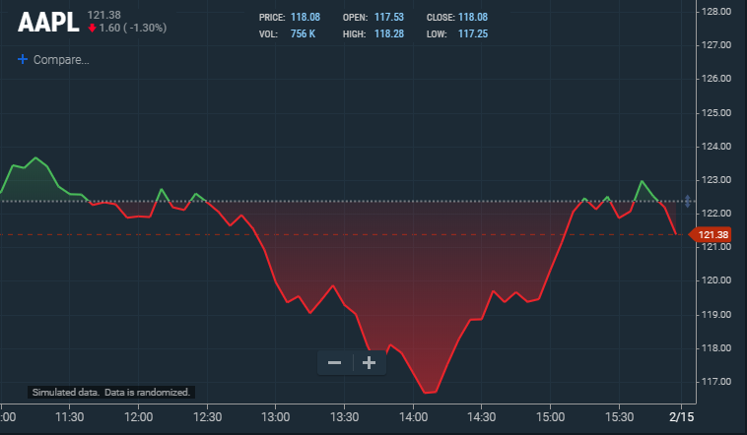

## Time series scatter

The time series scatter chart draws a single dot at every closing value for each time period and does not connect them.

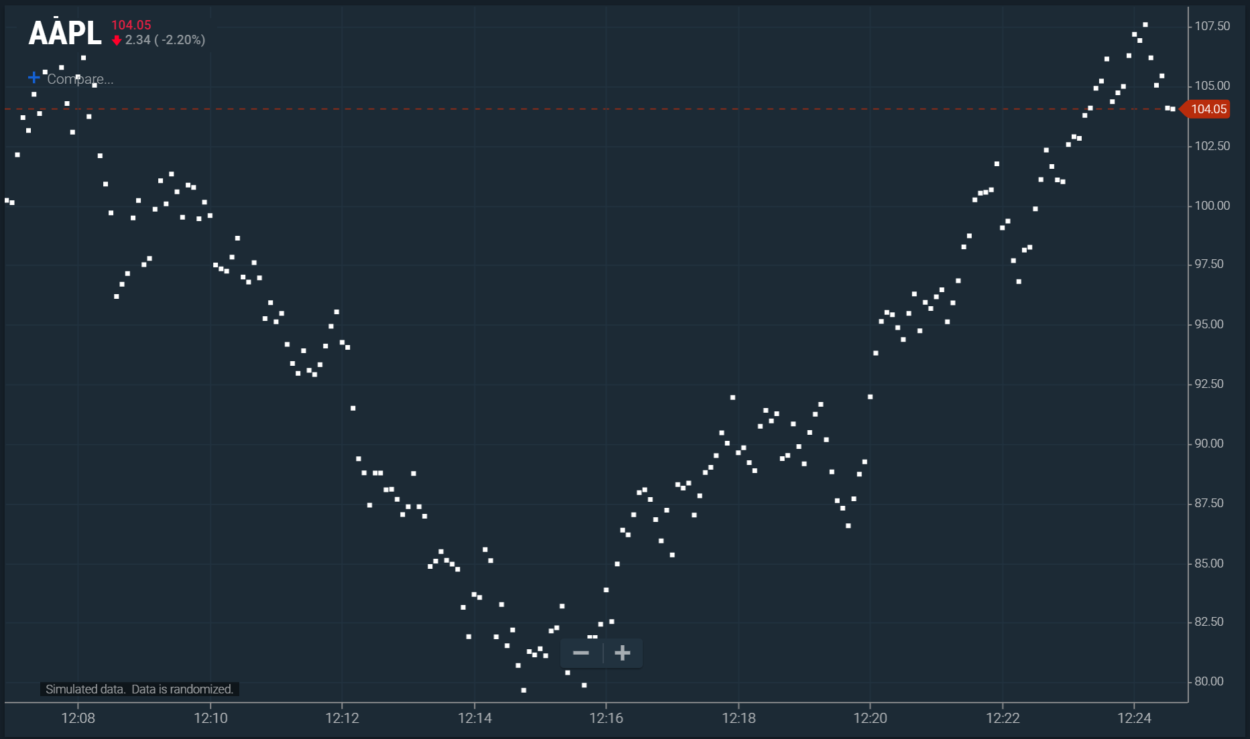

## HLC box chart

HLC box charts appear as a colored box with a line showing the close. The high price is the top of the box and the low is the bottom of the box. The intent of the HLC box design is to emphasize where the close is relative to high-low range. ChartIQ offers the ability to use different colors between the high-close and the close-low.

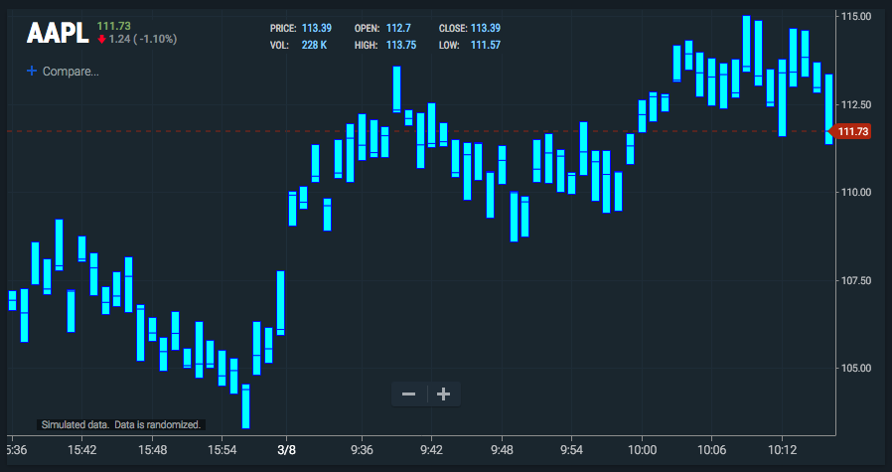

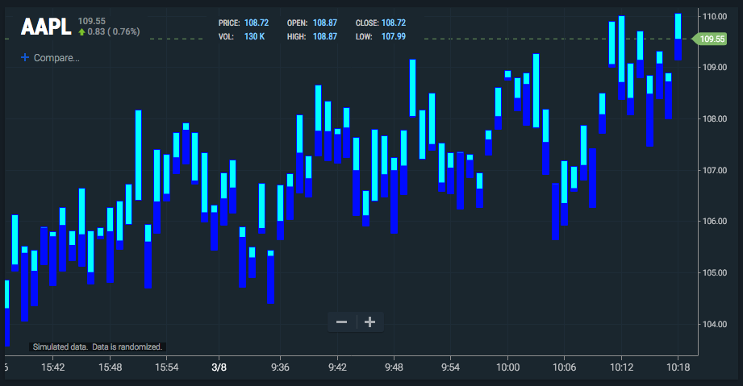

# Chart Types

Chart types offer alternative ways of viewing open-high-low-close (OHLC) data. Each chart type either aggregates data or applies a formula that transforms the data. Some charts are time independent, meaning that a single bar may encompass multiple bars of price movement, resulting in an x-axis that is not linear.

## Customizing chart types

Most chart types can be customized. To customize a chart type:

1. Open the **Display** menu.
2. Select the gear icon next to the chart type.
3. Enter values in the dialog box that appears. For example, for Kagi charts:

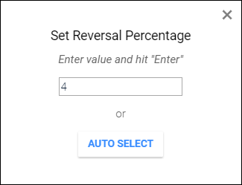

Select the **AUTO SELECT** button to let the chart determine the setting.

## Heikin-Ashi

Heikin-Ashi charts are time series charts that resemble candle charts. In a normal candle chart, each candle is calculated independent of the other candles. However, in Heikin-Ashi charts, the candles appear to link together because of how their OHLC values are calculated:

* Open = the mean of the previous open and the previous close
* High = the maximum of the current high, open, and close
* Low = the minimum of the current low, open, and close
* Close = the mean of the current open, close, high, and low

Upward trends are indicated by green candles with wicks on top, but almost no wick on bottom. Downward trends are indicated by red candles with wicks on the bottom and almost no wick on top. Reversal points are indicated by candles, red or green, with small bodies and wicks on top and bottom. This chart type can spot trends more clearly and easily than regular candle charts.

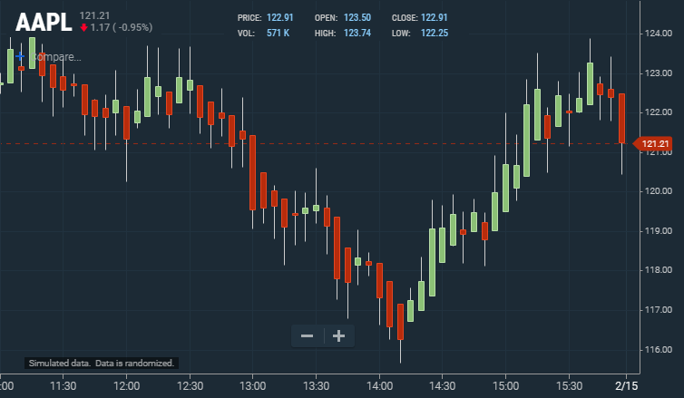

## Kagi

Kagi charts appear as vertical bars connected by small horizontal segments at right angles. Kagi charts are independent of time; they progress forward based on price action. Thick green lines, called yang bars, indicate that a price has broken out above the previous yin’s high price. Thin red bars, called yin bars, indicate that the price has fallen below the previous yang’s low. Unlike the other chart types, the colors of kagi lines do not directly communicate upward or downward trends.

Bars move upward or downward depending on closing prices. A bar will shift direction when a reversal limit is reached. Reversal limits are input by the user as a fixed percentage of the price. For example, imagine you have a stock valued at $10 and you are drawing a kagi chart with a reversal of 10%. Depending on what trend was established, a cumulative $1 movement in the opposite direction will break the current trend and cause a reversal.

Kagi charts can be customized (see Customizing chart types). Pressing the **AUTO SELECT** button of the customization dialog box sets the reversal limit to one of two defaults: if the chart is daily, a reversal of 4% is set; if the chart is intraday, a reversal of 0.4%.

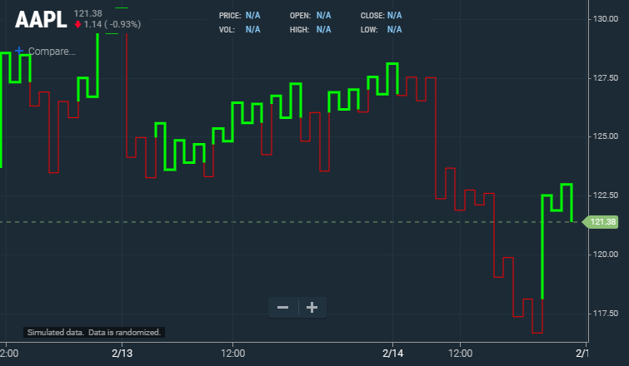

## Line break

Line break charts appear as vertical bars that ascend and descend. These charts are time independent and are determined only by price action. Ascending bars are colored green and indicate upward price action. Descending bars are colored red and indicate downward price action.

Line break charts are constructed by looking at the close of a bar and comparing it to a previous bar’s close; which bar it is compared to is determined by the user (see below). If the current bar’s close is higher than the one it is being compared to, a green ascending bar is drawn. If the current bar’s close is lower than the one that it is being compared to, a red descending bar is drawn. If the current close is the same, or if the price does not move enough in one direction or the other to signify a reversal, then no bar is drawn.

Line break charts default to a value of three, meaning that it compares the current bar’s close to the bar that came two periods earlier.

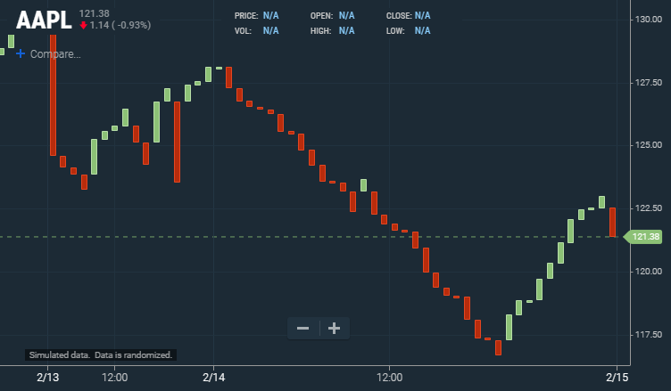

## Point and figure

Point and figure charts display an X for upward price action and an O for downward price movement. The X and O represent a specific price increment, known as the box size which is configured in properties by the user. The objective is to capture directional price trends without the impact of time. A new column is formed when price reverses a set number of boxes, that is a multiple of the box size. The reversal value is configured in properties by the user.

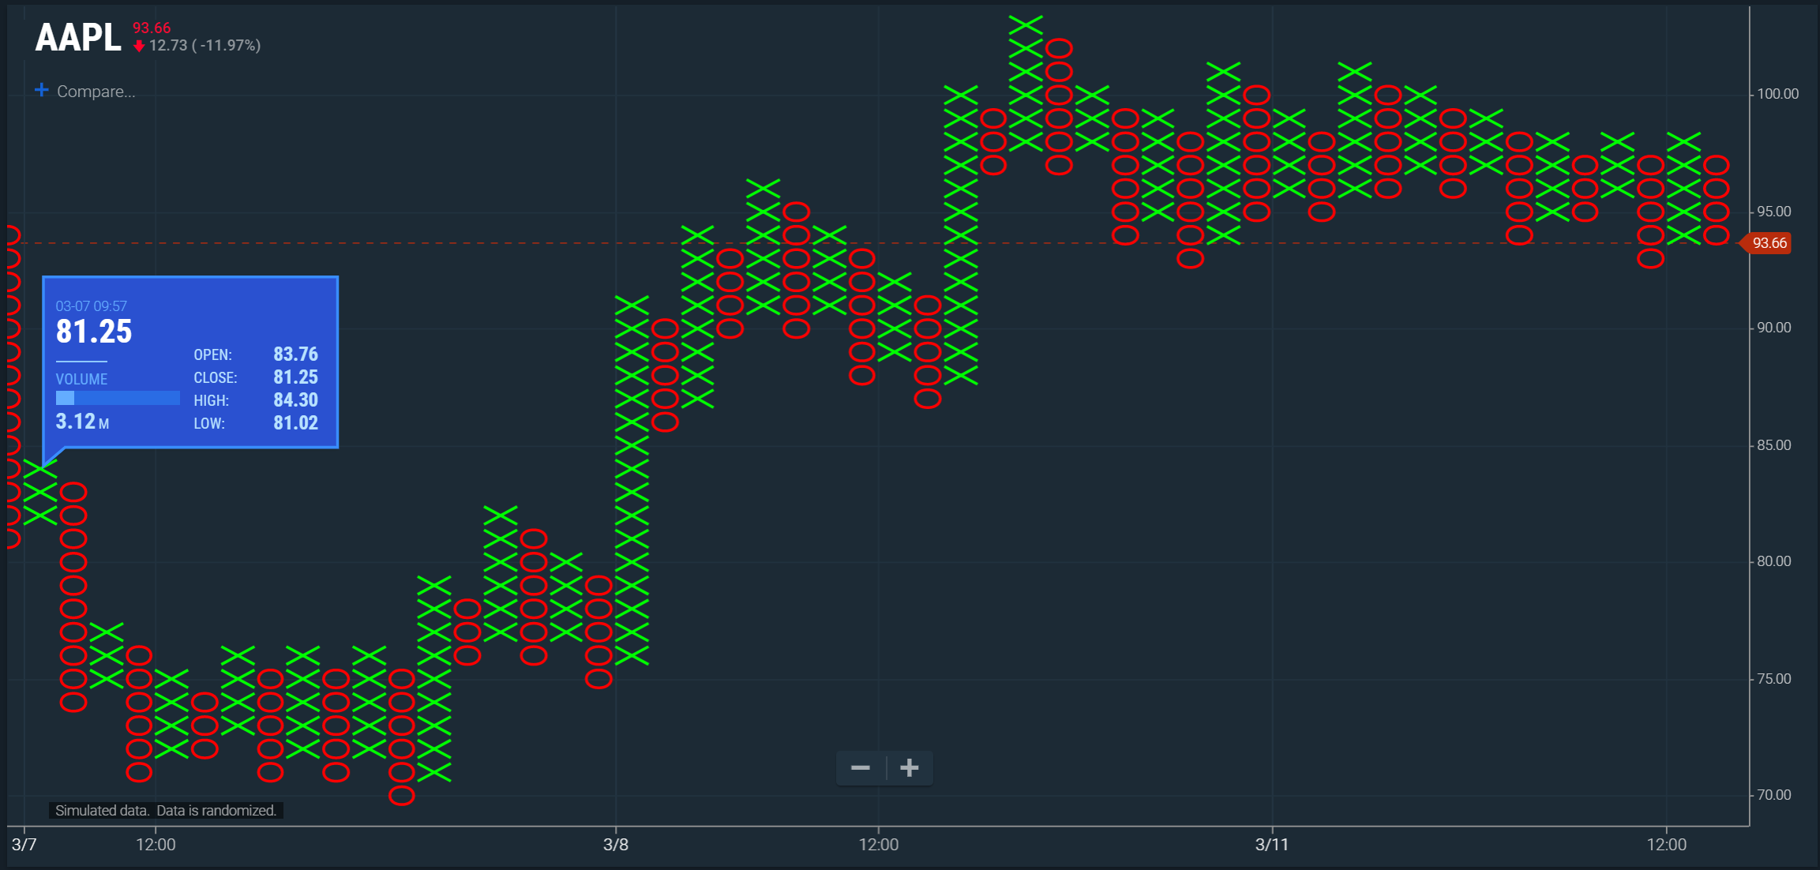

## Range bars

Range bar charts appear as a series of equally sized candles. A new bar is formed when the price moves outside of the user defined range, which is configured in **Set Range.**

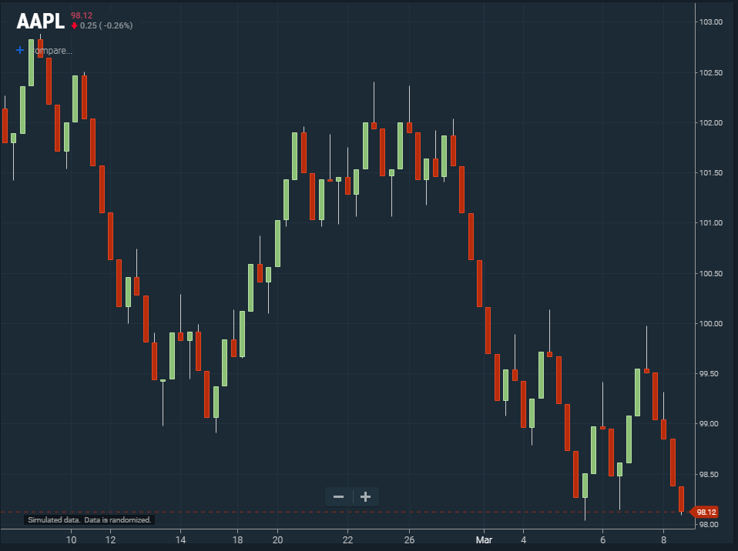

## Renko

Renko charts appear as a series of equally sized blocks stepping diagonally upward or downward. This chart type, developed by the Japanese, measures price movement independent of time. The objective is to clearly see the market’s directional movement, persistence, and magnitude. Renko charts are constructed from a series of bricks placed sequentially upward using green blocks or downward based on user-defined fluctuations in price. The user can set the **Brick Size** using the **Set Range** property. Once price moves more than the user-defined range, a new brick is added to the chart in the corresponding direction.

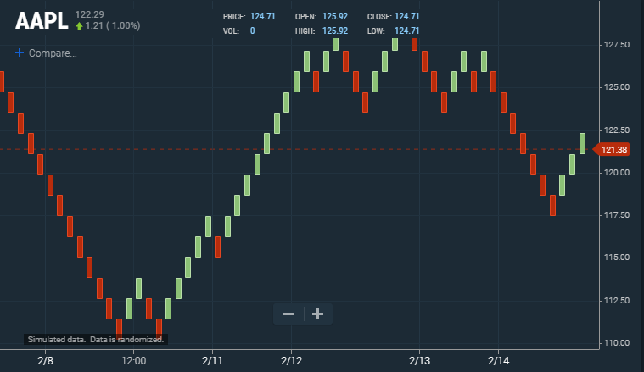

# Additional Charts

## Term Structure

Term structures are graphs of financial instrument values ordered by date of delivery. The Yield Curve chart, a type of term structure, compares U.S. Treasury yields at various maturity dates. The curve scales to show the relative time interval of maturity dates. Background shading highlights short-, mid-, and long-term instruments.

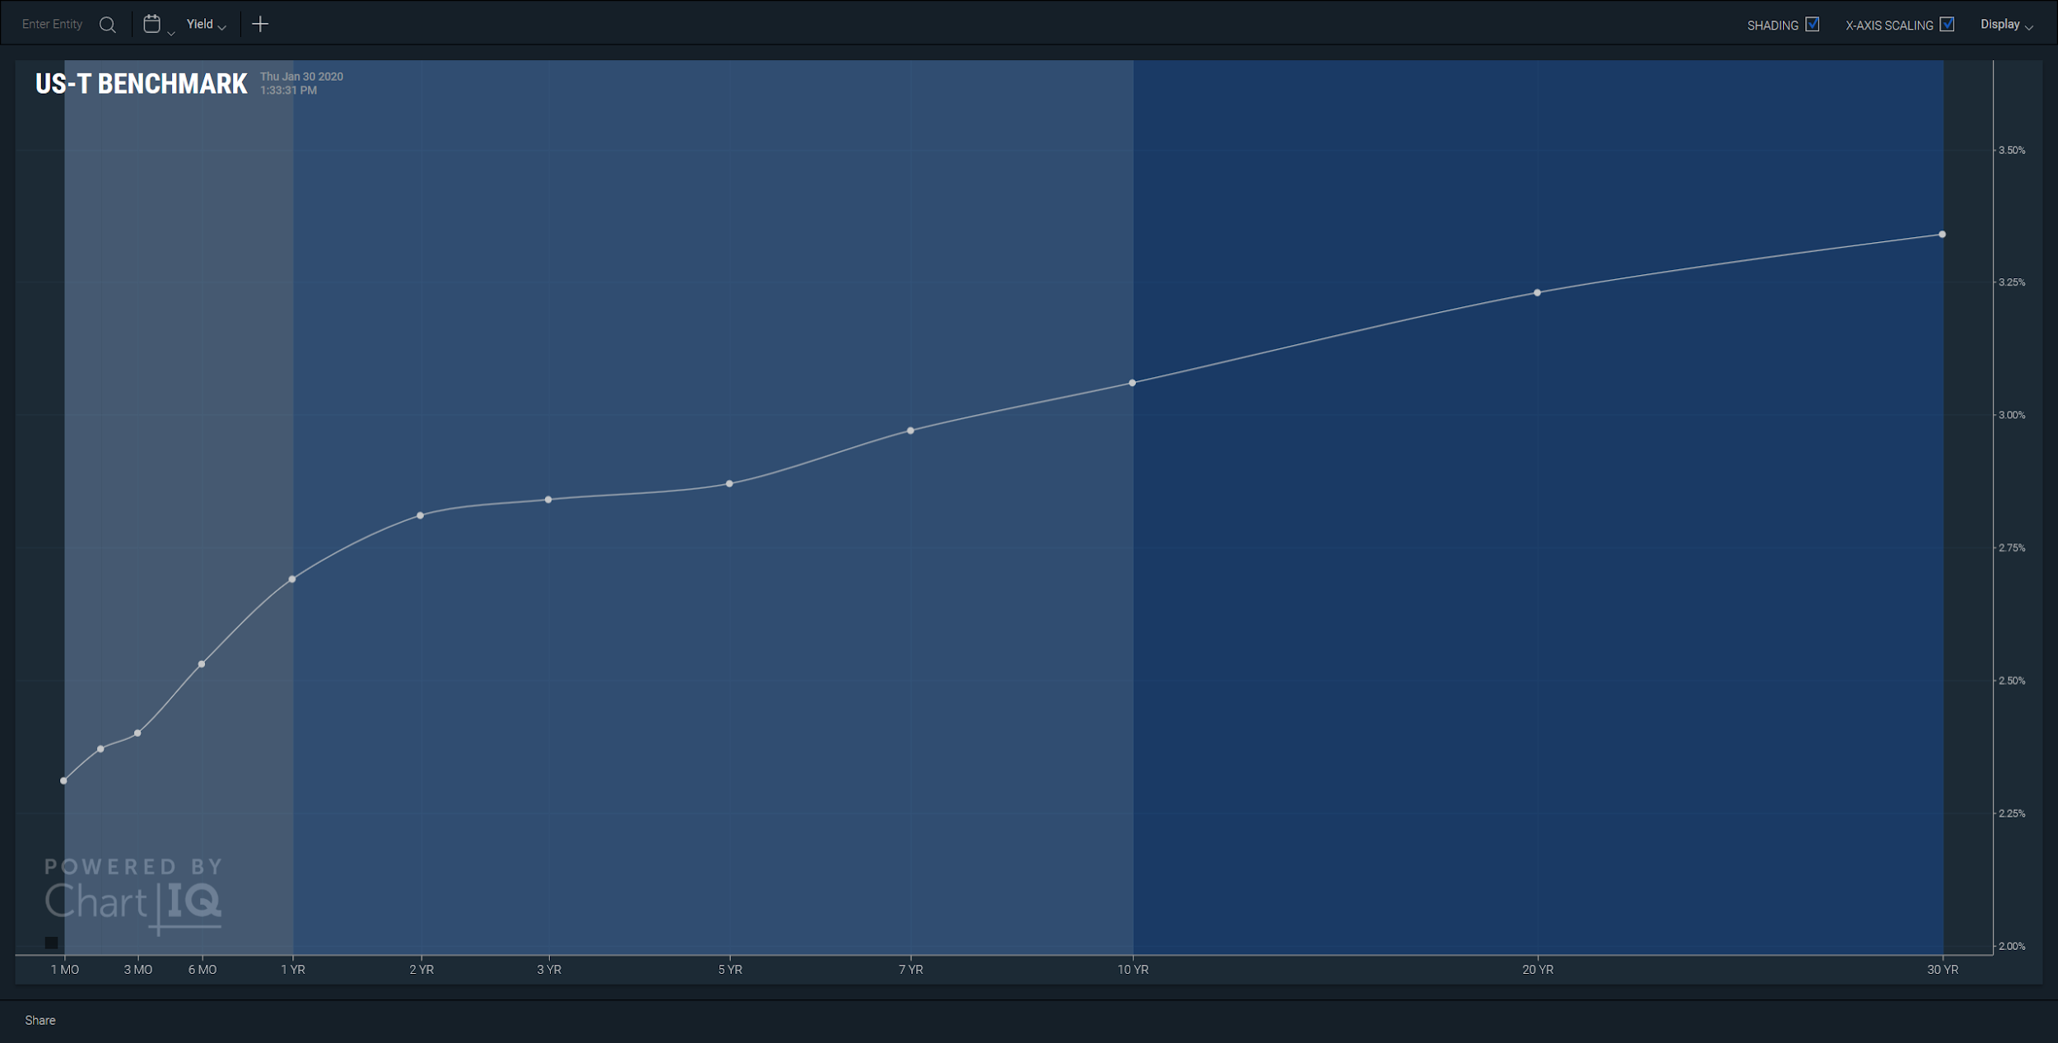

## Data Forecasting

Data forecasting enables the visualization of predicted outcomes by connecting historical and forecast data sets. Forecasts are graphed in a variety of distinctive line styles and colors, clearly distinguishing the forecast portion of a series or study from the historical data. A forecast can include a range of outcomes which may be displayed as a projection cone. Forecasts can be appended to any date up to the present to show the accuracy of past forecasts.

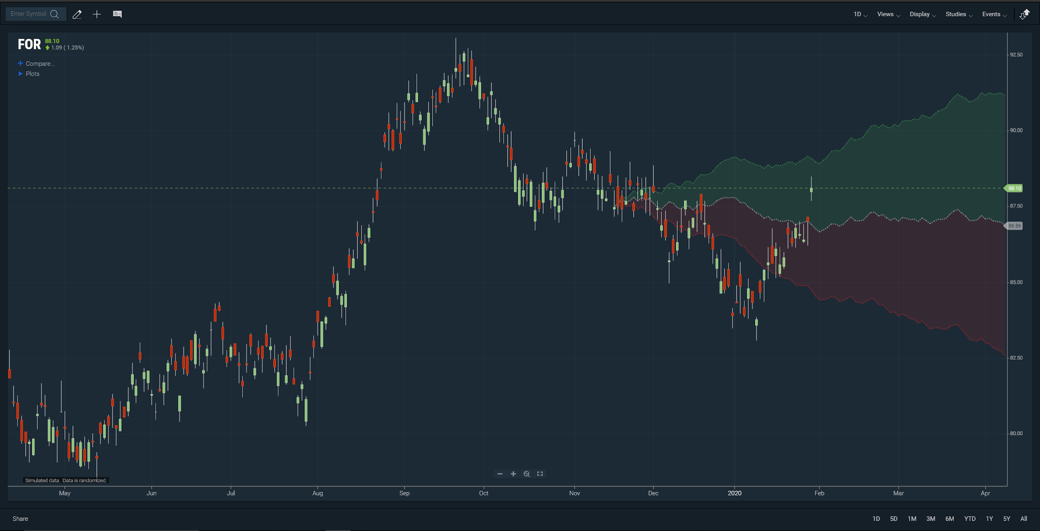

# Studies

The ChartIQ library includes over 100 studies, many of which support multiple lines and permutations, giving you exceptional technical analysis capabilities.

## Popular studies

Here are some of our most popular and most-used technical indicators.

### Anchored VWAP

Anchored VWAP derives the volume weighted average price from a given date and time. Unlike VWAP, the anchored VWAP can be applied to both intraday and historical price data. HLC3 is the default price used to derive Anchored VWAP.

***NEW v8.1*** Users can now set the anchor time using an interactive control. The control is a vertical line with a drag “handle” that enables users to select and drag left and right to set the anchor time. A checkbox in the study settings panel turns the anchor selector control on or off.

### Aroon / Aroon Oscillator

Aroon / Aroon Oscillator is used to identify the strength of a trend and especially when a trend is beginning.

* Indicator Type — Trend Finder
* Markets — All cash and futures, not options
* Works Best — All market types and time frames although daily is the most popular.
* Formula — The Aroon indicators are shown in percentage terms and fluctuate between 0 and 100. Aroon op is based on recent highs and Aroon down is based on recent lows. The Aroon oscillator is simply a plot of Aroon up minus Aroon down.
* Theory — Aroon means “dawn’s early light” in Sanskrit, a name chosen for the indicator’s ability to spot the beginning of a new trend, either higher or lower. Developed by Tushar Chande, both the Aroon up and the Aroon down fluctuate between 0 and 100, with high Aroon up values indicating a strong rising trend.

High Aroon down values indicate a strong falling trend. Zero indicates a no trend. The main assumption underlying this indicator is that a stock’s price will close at relative highs in an uptrend and relative lows in a downtrend. A 25-day Aroon up measures the number of days since a 25-day high. A 25-day Aroon down measures the number of days since a 25-day low. This means the indicator analyzes price relative to itself rather than price relative to time, as many other indicators measure. It can spot emerging trends, identify consolidations, and anticipate reversals.

### Average Directional Index and Directional Movement System (ADX/DMS)

ADX/DMS is used to identify the direction and strength of a trend.

* Indicator Type — Trend finder
* Markets — All cash and futures, not options
* Works Best — All markets and time frames, although this study can excel in determining if a visually flat market is starting to develop a trend.
* Formula — Directional movement (DM) is defined as the largest part of the current period’s price range that lies outside the previous period’s price range. Each period will either be positive (larger range above previous range), negative (larger range below previous range), or zero (price stay within the previous day’s range):
* The value of the plus directional indicator (+DI) is the DM (if above the previous range) divided by the average true range.
* The value of the minus directional indicator (-DI) is the DM (if below the previous range) divided by the average true range.
* Each period has only one result, either plus, minus, or zero. Calculate the average directional index by taking a simple moving average of the past +DI and -DI values. ChartIQ defaults to 14 periods.
* You can also select colors for the ADX, +DI, and –DI lines by selecting the appropriate box to bring up a color palette. Green and red are often used for +DI and –DI, respectively.
* Theory — Most technical tools fall into one of two categories: oscillators and trend followers. RSI and stochastics are examples of the former and moving averages and bands are examples of the latter. However, not all studies are effective in the different types of markets. Trend following studies often cause false signals, and hence losses, in flat or erratic markets. This study helps determine whether the market is in a trending mode and, if so, how strong that trend is so the proper technical tools can be applied. The study seeks to find if the item spent more time above or below its previous period’s range. In this case, more time really means a bigger foray in one direction or the other. If moves higher start to accumulate, even if closes are not really changing, we get an idea that bulls are trying to move the item higher.

### Average True Range (ATR)

ATR incorporates the change from the previous close into calculating the periods range (volatility).

* Indicator Type — Volatility measure
* Markets — All cash and futures
* Works Best — All market types in daily and weekly time frames, although it can be used intraday, as well.
* Formula — The true range is the largest absolute value of:
* current high minus previous close
* current low minus previous close
* current high minus current low
* Theory — Although it can be used alone to help determine a market’s volatility, ATR is usually used as a qualifier in other indicators by, for example, adapting their parameters to a stock’s volatility. A stock experiencing a high level of volatility will have a higher ATR and a low volatility stock will have a lower ATR. In any time period, the range is often used as a measure of volatility. However, if the range occurred at a significantly different level than the prior range the jump up or down would not be factored in using simple range formulas. Intraday time frames do not see the jumping or gapping action as daily or weekly time frames so ATR would be less important there.

### Bollinger Bands

Bollinger bands are used to find market turning points, potential trading range breakouts, and trend exhaustion.

* Indicator Type — Moving average envelope
* Markets — All cash and futures, not options
* Works Best — All market types and time frames although daily is the most popular
* Formula — The bands form an envelope, drawn a number of standard deviations above and below a moving average.
* Theory **—** The theory behind the bands is that the width of an envelope should be determined by the data-series itself rather than by the assumptions of the speculator, as done with percent envelopes. In this way, the envelope’s distance from the mean is a function of the market’s volatility.

### GoNoGo Trend

***NEW v8.7*** The GoNoGo Trend study colors the price action of any security according to the strength of its trend, making it simple to identify and interpret the current trend:

* Bright Blue price bars indicate the strongest bullish environment.
* Aqua bars are slightly less bullish; they often occur at the start of a new trend, or as a strong bullish trend begins to weaken.
* Amber bars represent uncertainty, often appearing in the transition from bull trend to bear trend and vice versa.
* Pink bars indicate a lower intensity bearish environment
* Dark Purple bars are shown when the bearish trend intensifies.

The “Go” and “NoGo” labels on the chart mark transitions to bull or bear trends, respectively.

### Moving Average

Moving averages are used to smooth out market volatility and identify changes in trend.

* Indicator Type — Trend follower
* Markets — All cash and futures, not options
* Works Best — Trending markets
* Formula — Moving averages can be calculated from open, high, low, close or some combination of these values. Simple averages are statistical means of the data. Other averages assign higher significance to recent data than to older data.
* Theory — The direction of the moving average (higher, lower, or flat) indicates the trend of the market and its slope indicates the strength of the trend. Longer averages are used to identify long-term trends and shorter averages are used to identify short-term trends. Many trading systems utilize moving averages as independent variables, and market analysts frequently use moving averages to confirm technical breakouts.

You have a choice of several average types:

* Simple — Mean (average) of the data.
* Exponential — Newer data is weighted more heavily geometrically.
* Time series — Calculates a linear regression trend line using the “least squares fit” method.
* Triangular — Weighted average where the middle data are given the most weight, decreasing linearly to the end points.
* Variable — An exponential moving average with a volatility index factored into the smoothing formula. The variable moving average uses the Chande Momentum Oscillator as the volatility index.
* VIDYA — An exponential moving average with a volatility index factored into the smoothing formula. The VIDYA (Volatility Index Dynamic Average) moving average uses the standard deviation as the volatility index.
* Weighted — Newer data are weighted more heavily arithmetically.
* Welles wilder — The standard exponential moving average formula converts the time period to a fraction using the formula EMA% = 2/(n + 1) where n is the number of days. For example, the EMA% for 14 days is 2/(14 days +1) = 13.3%. Wilder, however, uses an EMA% of 1/14 (1/n) which equals 7.1%. This equates to a 27-day exponential moving average using the standard formula.

### Moving Average Convergence Divergence (MACD)

MACD is used to identify overbought and oversold conditions.

* Indicator Type — Momentum oscillator
* Markets — All cash and futures, not options
* Works Best — Wide-swinging trading ranges and at the conclusion of strong trends
* Formula — The MACD indicator makes use of three moving averages, usually of the exponential variety. Two are averages of price, and the third is an average of the difference of the other two. The MACD line is generated from the first two averages, subtracting the longer from the shorter. The signal line is simply a moving average of the MACD line.
* Theory — In an upward and smoothly trending market, a longer average will be increasing. A short average, being more sensitive to normal price fluctuations within the trend, will show more changes in direction. If the two averages are plotted together, the shorter average will oscillate around the longer average. A strong near-term rally will cause the difference between the two moving averages to increase until an extreme value is reached. This signals an overbought condition. Conversely, in a down market, spreads will become negative until an extreme is reached, indicating an oversold condition.

### Option Sentiment by Strike

***NEW v8.1*** The Option Sentiment by Strike study enables traders to quickly interpret options activity for a security.

* Indicator Type — Price Support and Resistance
* Markets — Listed markets with options contracts
* Works Best — Historical periodicities
* Formula — The study overlays a profile of the volume or open interest of option contracts at each strike price for a security’s most current data point. Calls and puts are graphed as separate, adjacent horizontal bars, allowing the user to understand any bias within the two option types.
* Theory — Displaying the actual market activity within a security’s corresponding derivative market allows the user to understand positioning and bias within that market. The study may be combined with any other price-based analytics to understand market support and resistance points.

***Figure.***Option Sentiment by Strike study showing volume of calls (tan bar) and puts (purple bar) at various strike prices.

### Projected Aggregate Volume

***NEW v8.0*** Projected Aggregate Volume (PAV) is an aggregation of the day’s trading volume up to the current time along with a projection of the aggregate volume for the remainder of the trading day. The study reveals whether the trend in trading volume is above or below average and provides a forecast of volume for the rest of the day. **Note:** This study is displayed ONLY for intraday periodicities.

* Indicator Type — Intraday activity indicator.
* Markets — All exchange-traded instruments with liquidity throughout the trading day.
* Works Best — Intraday analysis of equities and futures.
* Theory — The study enables traders to identify unusual volume activity in real time. Traders can see whether today’s aggregate volume activity is above or below average relative to recent activity.

The PAV study displays two lines:

* Aggregate Volume — Vertical bars showing the summation of today’s volume up to the current time.
* Projected Aggregate Volume — An overlay line showing the average aggregate volume based on trading in the past N days. That is, for a 30-minute chart with lookback = 10, the study retrieves and aggregates the volume for 9:30-10:00, 10:00-10:30, 10:30-11:00, etc. for the past 10 days. The projection shows how much volume trades on average for the time remaining.

Parameters

* Lookback Days — The number of days used to calculate the Projected Aggregate Volume line.
* Anchor Time — The user may enter a time (when the order arrives) to display values from that time to the end of the trading day. That is, the anchor time serves to reset the volume calculation at zero and sum the values moving forward until the close of trading.

***NEW v8.1*** The anchor time is now the market open time. The anchor time changes automatically for on-screen studies when the chart symbol changes from market to market; for example, from a stock symbol to a Forex symbol.

***NEW v8.1*** Users can now set the anchor time using an interactive control. The control is a vertical line with a drag “handle” that enables users to select and drag left and right to set the anchor time. A checkbox in the study settings panel turns the anchor selector control on or off.

***Figure.*** *PAV study showing aggregated trading volume bar graph and moving average line.*

### Projected Volume at Time

***NEW v8.0*** Projected Volume at Time (PVAT) is an average of intraday trading volume for each given time segment. **Note:** This study is displayed ONLY for intraday periodicities.

* Indicator Type — Intraday activity indicator.
* Markets — All exchange-traded instruments with liquidity throughout the trading day.
* Works Best — Intraday analysis of equities and futures.
* Theory — The study enables traders to identify unusual volume activity in real time. Traders can see whether the current volume activity is above or below average for that time and see projected volume for each time segment of the day.

The PVAT study displays two lines:

* Volume — Vertical bars showing today’s volume for each intraday time segment (standard volume panel).
* Average Volume at Time — An overlay of average volume for each time segment based on trading in the past N days. That is, for a 30-minute chart with lookback = 10, the study retrieves and averages the volume for 9:30-10:00, 10:00-10:30, 10:30-11:00, etc. for the past 10 days.

Parameters

* Lookback Days — The number of days used to calculate the Average Volume at Time line.
* Alert Threshold — The volume bars are highlighted when the volume exceeds the average volume by a user-defined percentage.
* Anchor Time — The user may enter a time (when the order arrives) to display values from that time to the end of the trading day.

***NEW v8.1*** The anchor time is now the market open time. The anchor time changes automatically for on-screen studies when the chart symbol changes from market to market; for example, from a stock symbol to a Forex symbol.

***NEW v8.1*** Users can now set the anchor time using an interactive control. The control is a vertical line with a drag “handle” that enables users to select and drag left and right to set the anchor time. A checkbox in the study settings panel turns the anchor selector control on or off.

***Figure.*** *PVAT study showing trading volume bar graph and moving average line.*

### Relative Strength Index (RSI)

RSI is used to measure underlying strength of a market move.

* Indicator Type — Momentum oscillator
* Markets — All cash and futures, not options
* Works Best — Trending markets, all time frames
* Formula — The RSI looks at a ratio of average size of the up-closes over the past *n* periods and compares to the average size of the down-closes. The result is indexed between 0 and 100. RSI values are smoothed exponentially using the same *n* period parameter.
* Theory — Prices are generally considered to be elastic in that they can move only so far from a mean price before reacting or retracing. The slope and values of the RSI are directly proportional to the velocity and magnitude of the price move and are extremely helpful in identifying overbought and oversold situations. The number of periods (days, hours, five minutes) was originally based on half of a normal cycle. For example, Welles Wilder originally presumed Gold to have a 28-day cycle, so a 14-day RSI was used. This has been replaced by the speed of the market. Faster markets use smaller (more sensitive) parameters.

### Stochastics

Stochastics is used to identify market strength, overbought/oversold.

* Indicator Type — Momentum oscillator
* Markets — All cash and futures, not options
* Works Best — Flat markets or trading ranges
* Formula — The calculation (fast) tells us where price is in its recent range. It is then smoothed with a three-period moving average (slow) leaving both lines on the chart. Most traders smooth the smoothed line again to create a slower version of the indicators.
* Theory — A stochastic is the measurement of the placement of a current price within a recent trading range. The theory is that, as prices rise, daily (or hourly, minute, etc.) closes tend to occur closer to the high end of their recent range. When prices trend higher or flat and daily closes begin to sag within the range, it signals internal market weakness.

### Supertrend

Supertrend is used to time buys and sells based on changes in the trend.

* Indicator Type — Trend following indicator
* Markets — All cash and futures, not options. Most popular in forex.
* Works Best — Trending markets
* Formula — The upper band is the average price plus the volatility-based multiplier (usually [average true range](https://technicianapp.com/resources/average-true-range-atr/), or ATR). The lower band is the average price minus the volatility-based multiplier. Only one band is drawn for any period and it switches when price crosses it, similar to the [parabolic stop-and-reverse](https://technicianapp.com/resources/parabolic-sar/). Like any trailing stop, the upper band can never move higher once established, and the lower band can never move lower once established. Each is continued at the same price level as the previous period. Arrows are drawn pointing to the close of the bar when direction changes.
* Theory — The supertrend indicator measures trend direction but not strength. It gives buy or sell signals when price crosses the indicator. In a sense, it is like a moving average and trailing stop hybrid. Since the indicator flips sides from above to below price action and back, it adds an element of the parabolics stop-and-reverse for actually making the trade. Because it measures trends, it is not useful during flat or choppy markets.

### Volume

Volume is used to quantify trading activity each period in a market, market sector, or individual instrument. It can be added as an underlay on the chart or in a separate window.

* Indicator Type — Activity indicator
* Markets — All cash, futures, and options, although futures and forex may substitute end of day summaries and trade count data.
* Works Best — All markets and time frames.
* Theory — Volume is simply the number of shares, contracts, or units changing hands in a given period (day, week, hour). It is reported in real-time (or delayed) with each trade. Markets that do not have trade-by-trade reported volume substitute daily summary data or trade count data. Trending markets should be accompanied by rising volume. Exhausted markets are usually accompanied by falling volume or unusually high-volume spikes.

## All studies

The following is a list of all the technical indicators included in the ChartIQ library.

See the [Built-In Studies Reference Guide](https://documentation.chartiq.com/tutorial-Using%20and%20Customizing%20Studies%20-%20Definitions.html) for detailed information.

| **Name** | **Short Name** | **Features** |
| --- | --- | --- |
| ADX/DMS | ADX |  |
| ATR Bands | ATR Bands |  |
| ATR Trailing Stops | ATR Trailing Stop |  |
| Accumulation/Distribution | W Acc Dist |  |
| Accumulative Swing Index | Acc Swing |  |
| Alligator | Alligator | The Alligator study can now hide its Jaw, Teeth, and Lips lines, enabling users to show only the Fractal arrows to emphasize trading signals. To hide the lines, clear the Show Lines check box in the study settings panel.    **Note:** The Alligator study is part of the Technical Analysis Charting Package. |
| Anchored VWAP  (Anchored Volume Weighted Average Price) | AVWAP |  |
| Aroon | Aroon |  |
| Aroon Oscillator | Aroon Osc |  |
| Average True Range | ATR |  |
| Awesome Oscillator | Awesome |  |
| Balance of Power | Bal Pwr |  |
| Beta | Beta |  |
| Bollinger %b | Boll %b |  |
| Bollinger Bands | Bollinger Bands |  |
| Bollinger Bandwidth | Boll BW |  |
| Center of Gravity | COG |  |
| Chaikin Money Flow | Chaikin MF |  |
| Chaikin Volatility | Chaikin Vol |  |
| Chande Forecast Oscillator | Chande Fcst |  |
| Chande Momentum Oscillator | Chande Mtm |  |
| Choppiness Index | Choppiness |  |
| Commodity Channel Index | CCI |  |
| Coppock Curve | Coppock |  |
| Correlation Coefficient | correl |  |
| Darvas Box | Darvas |  |
| Depth of Market | DoM |  |
| Detrended Price Oscillator | Detrended |  |
| Disparity Index | Disparity |  |
| Donchian Channel | Donchian Channel |  |
| Donchian Width | Donchian Width |  |
| Ease of Movement | EOM |  |
| Ehler Fisher Transform | Ehler Fisher |  |
| Elder Force Index | Elder Force |  |
| Elder Impulse System | Elder Impulse |  |
| Elder Ray Index | Elder Ray |  |
| Fractal Chaos Bands | Fractal Chaos Bands |  |
| Fractal Chaos Oscillator | Fractal Chaos |  |
| GoNoGo - Trend | GoNoGo Trend |  |
| Gator Oscillator | Gator |  |
| Gopalakrishnan Range Index | GAPO |  |
| Guppy Multiple Moving Average | GMMA |  |
| High Low Bands | High Low |  |
| High Minus Low | High-Low |  |
| Highest High Value | HHV |  |
| Historical Volatility | Hist Vol |  |
| Ichimoku Clouds | Ichimoku Clouds |  |
| Intraday Momentum Index | Intraday Mtm |  |
| Keltner Channel | Keltner |  |
| Klinger Volume Oscillator | Klinger |  |
| Linear Reg Forecast | Lin Fcst |  |
| Linear Reg Intercept | Lin Incpt |  |
| Linear Reg R2 | Lin R2 |  |
| Linear Reg Slope | LR Slope |  |
| Lowest Low Value | LLV |  |
| MACD | macd |  |
| Market Facilitation Index | W MFI |  |
| Mass Index | Mass Idx |  |
| Median Price | Med Price |  |
| Momentum Indicator | Momentum |  |
| Money Flow Index | M Flow |  |
| Moving Average | ma |  |
| Moving Average Crossover | MAC |  |
| Moving Average Deviation | MA Dev |  |
| Moving Average Envelope | MA Env |  |
| Negative Volume Index | Neg Vol |  |
| On Balance Volume | On Bal Vol |  |
| Parabolic SAR | PSAR |  |
| Performance Index | Perf Idx |  |
| Pivot Points | Pivot Points |  |
| Positive Volume Index | Pos Vol |  |
| Pretty Good Oscillator | Pretty Good |  |
| Price Momentum Oscillator | PMO |  |
| Price Oscillator | Price Osc |  |
| Price Rate of Change | Price ROC |  |
| Price Relative | P Rel |  |
| Price Volume Trend | Price Vol |  |
| Prime Number Bands | Prime Number Bands |  |
| Prime Number Oscillator | Prime Number |  |
| Pring’s Know Sure Thing | Pring KST |  |
| Pring’s Special K | Pring Sp-K |  |
| Projected Aggregate Volume | PAV | Customizable lookback days and anchor time. Customizable colors for average line and bar graph. See Projected Aggregate Volume above. |
| Projected Volume at Time | PVAT | Customizable lookback days, anchor time, and alert threshold. Customizable colors for average line and bar graph. See Projected Volume at Time above. |
| Psychological Line | PSY |  |
| QStick | QStick |  |
| RAVI | RAVI |  |
| RSI | rsi |  |
| Rainbow Moving Average | Rainbow MA |  |
| Rainbow Oscillator | Rainbow Osc |  |
| Random Walk Index | Random Walk |  |
| Relative Vigor Index | Rel Vig |  |
| Relative Volatility | Rel Vol |  |
| STARC Bands | STARC Bands |  |
| Schaff Trend Cycle | Schaff |  |
| Shinohara Intensity Ratio | Shinohara |  |
| Standard Deviation | STD Dev |  |
| Stochastic Momentum Index | Stch Mtm |  |
| Stochastics | stochastics |  |
| Supertrend | Supertrend |  |
| Swing Index | Swing |  |
| TRIX | TRIX |  |
| Time Series Forecast | Time Fcst |  |
| Trade Volume Index | Trade Vol |  |
| Trend Intensity Index | Trend Int |  |
| True Range | True Range |  |
| Twiggs Money Flow | Twiggs |  |
| Typical Price | Typical Price |  |
| Ulcer Index | Ulcer |  |
| Ultimate Oscillator | Ultimate |  |
| VWAP | VWAP |  |
| Valuation Lines | val lines |  |
| Vertical Horizontal Filter | VT HZ Filter |  |
| Volatility Projection Cone | Volatility Projection Cone |  |
| Volume Chart | volume |  |
| Volume Oscillator | Vol Osc |  |
| Volume Profile | vol profile |  |
| Volume Rate of Change | Vol ROC |  |
| Volume Underlay | vol undr |  |
| Vortex Indicator | Vortex |  |
| Weighted Close | Weighted Close |  |
| Williams %R | Williams %R |  |
| ZigZag | ZigZag |  |